Activities and Hands On Projects – Chapter 3 Worksheet:

Name: Arnold Marten

Activity 3.1 – Windows Server 2022 Install

In this activity, we will be doing something very similar to what the book has us doing, just with a more recent version of Windows – Windows Server 2022. The steps are very similar, it will just look slightly different.
- Submit a screenshot of the completed installation (step 7):
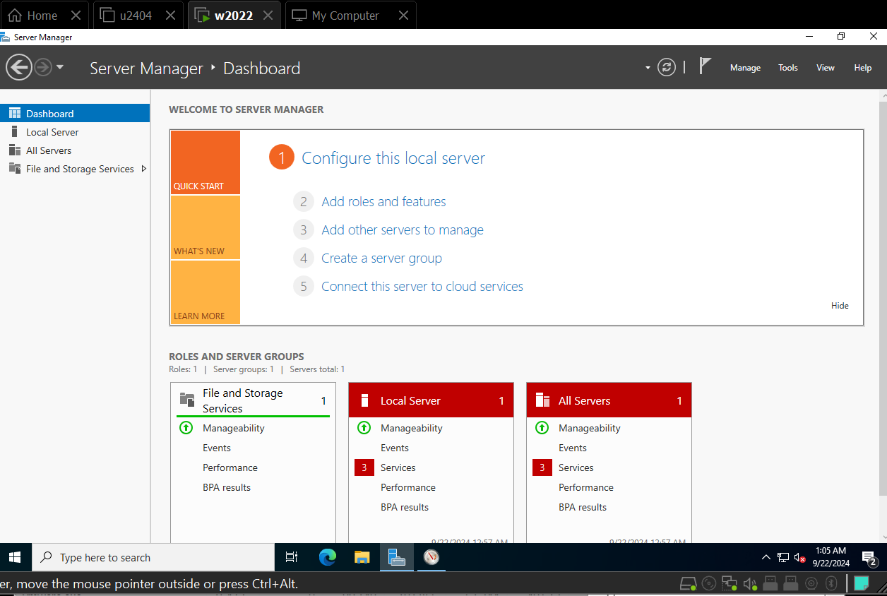

- Submit a screenshot of the Static IP assignment (step 10 – ping):
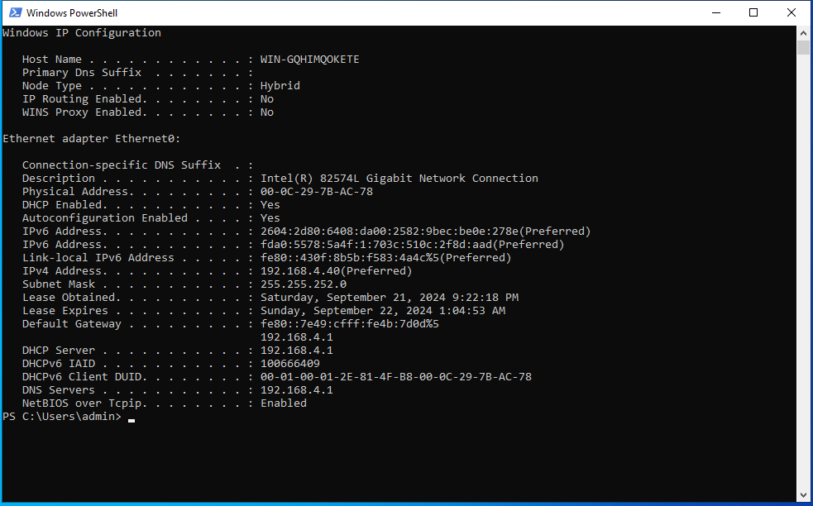

- Submit a screenshot of the Computer name (step 12 – Sever Manager, Local Server property):
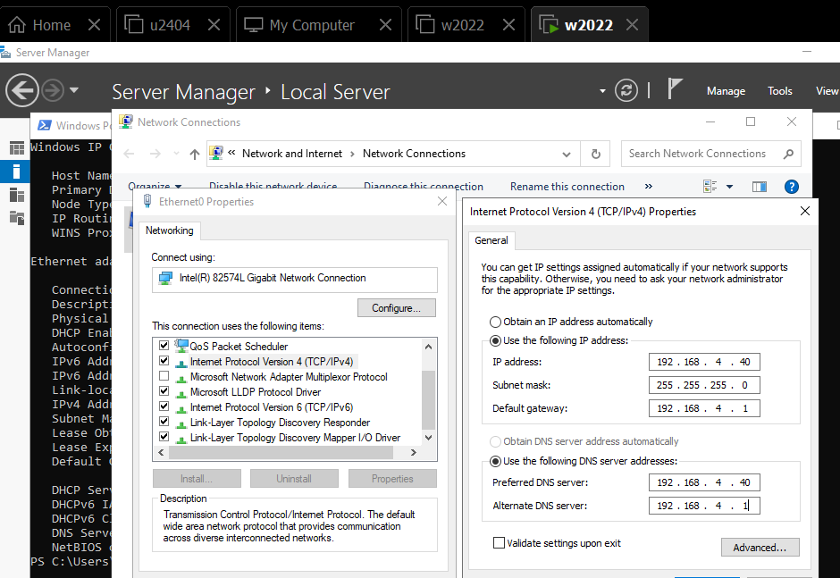

Activity 3.2 – Windows Server 2022 Basic Commands and Navigation

- Submit a screenshot of ‘whoami’ (step 3):
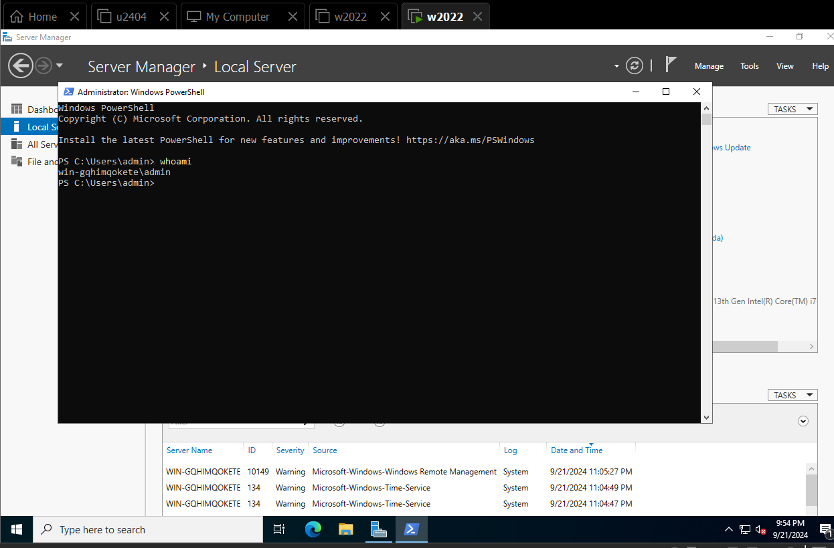

- Submit a screenshot of Resource Monitor (step 4):

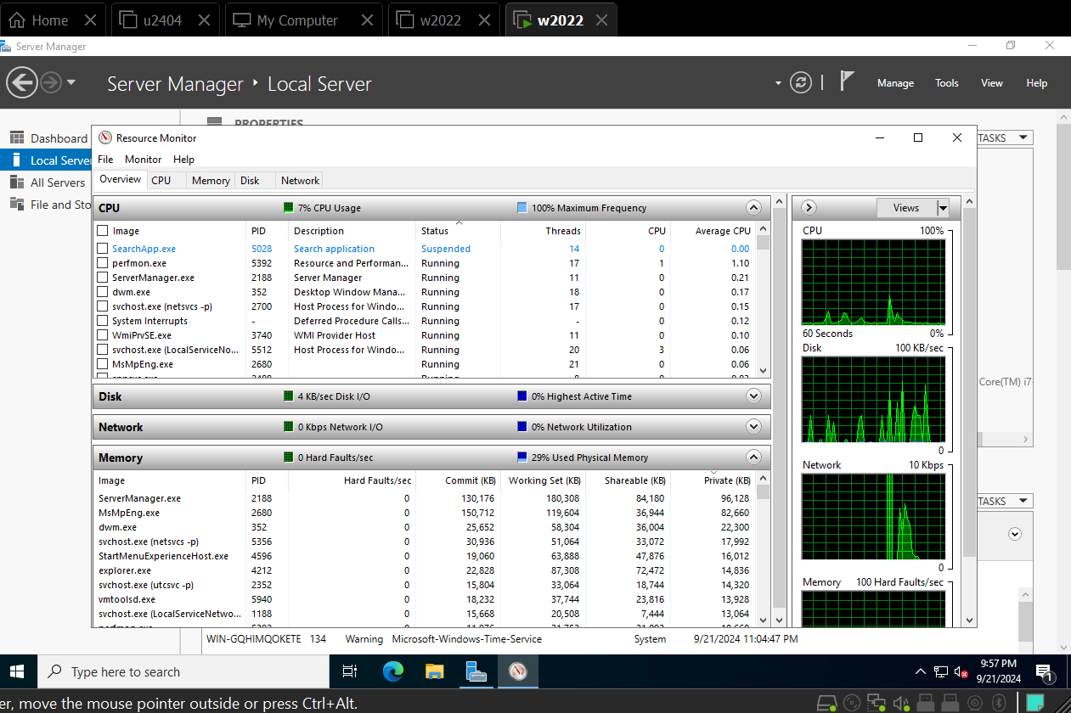

Activity 3.3 – Ubuntu 22.04 Install:

In this activity, we will be doing something very similar to what the book has us doing, just with a more recent version of Ubuntu Desktop – Ubuntu Desktop 22.04. The steps are very similar, it will just look slightly different.
- Submit a screenshot of the completed installation (step 7):
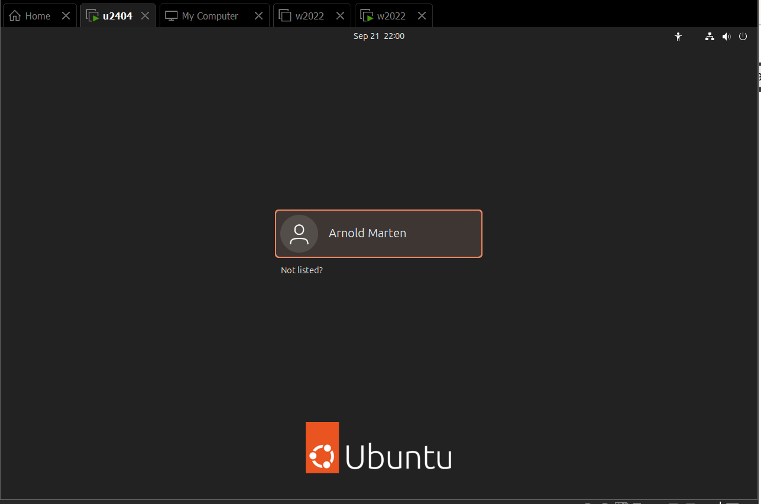
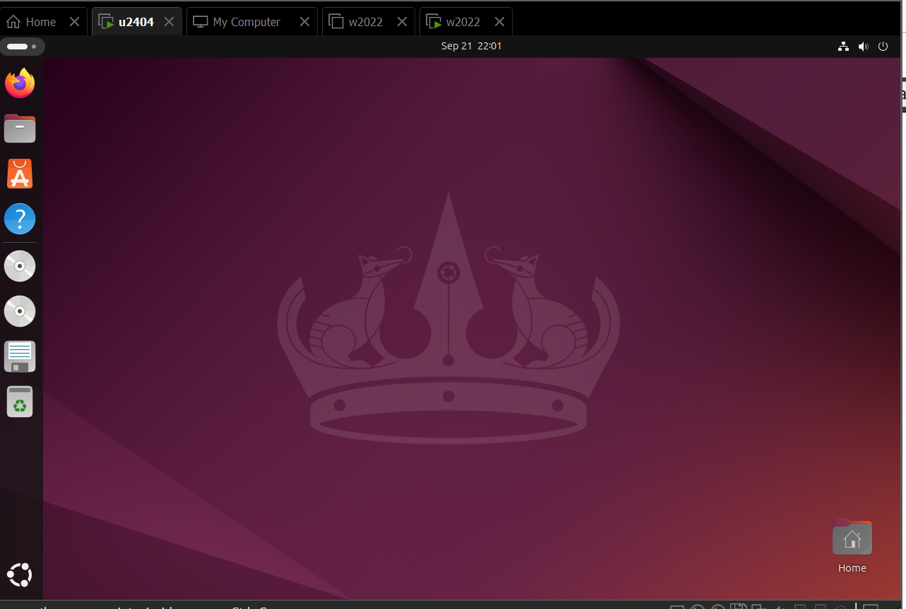
- Submit a screenshot of the Computer name (step 10 – sudo hostname):
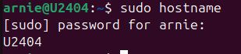

- Submit a screenshot of the Static IP assignment (from lecture):
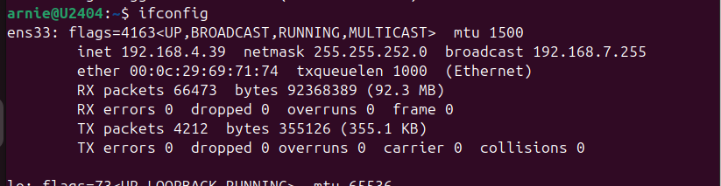
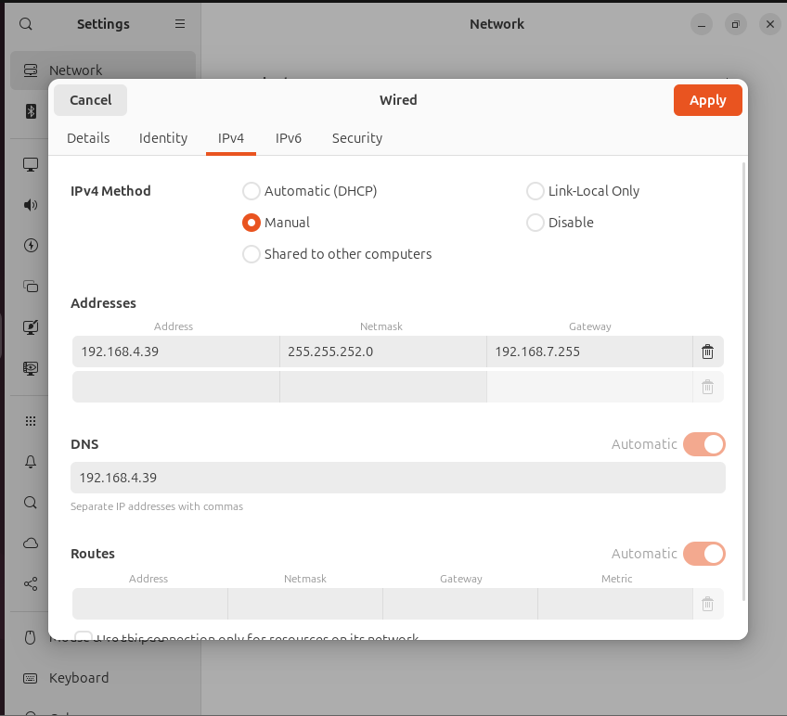

Hands On Projects:
3.1 Performance Monitoring W2022 and backup.
Resource Monitor (resmon) measures the four most important dimensions of performance: CPU, Disk, Network and Memory. Resmon lets you manage your machine performance by monitoring tasks such that CPU & Memory don’t exceed 70% on either your host or guest system. Also, with resmon performance stats, you can use the Virtual Machine Settings to balance CPU and Memory resources between your host and guest systems.
1. Run Resource Monitor (resmon) on your host and on your Windows Server guest and make note of the CPU usage & Physical Memory used.
- Go to your Virtual Machine Settings, fine tune your VM and screen shot your settings
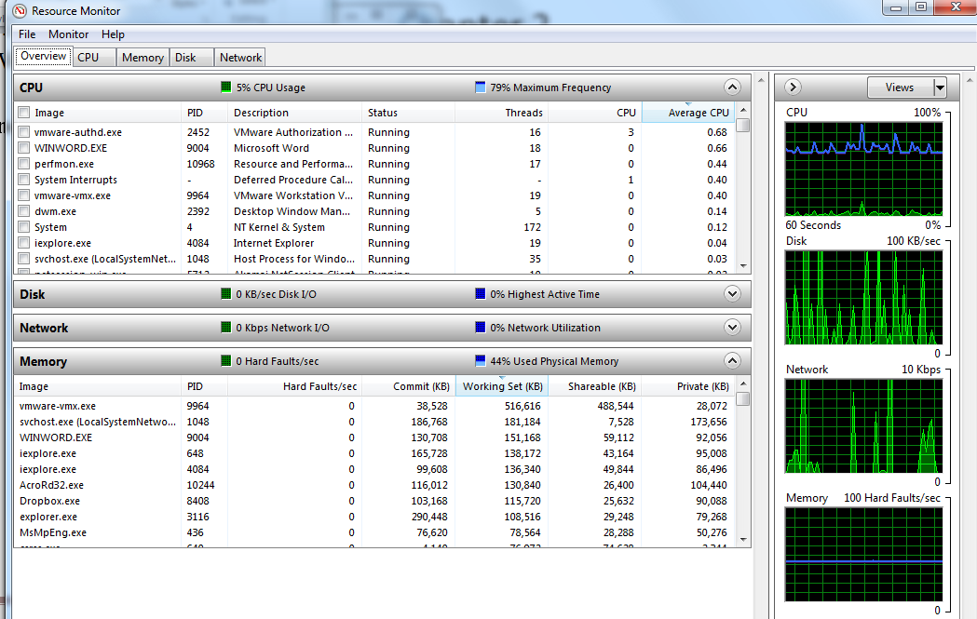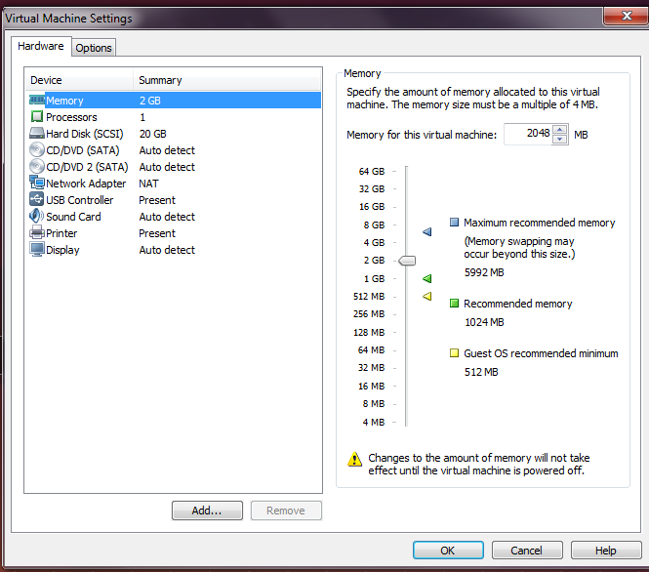
By default your virtual machine (VM) can be found in \Documents\Virtual Machines. If you back up your VM folder at the end of each chapter, you’ll never risk losing more than one chapter of work.

- Backup your Windows Server VM and insert a screenshot of the properties of your backup folder.

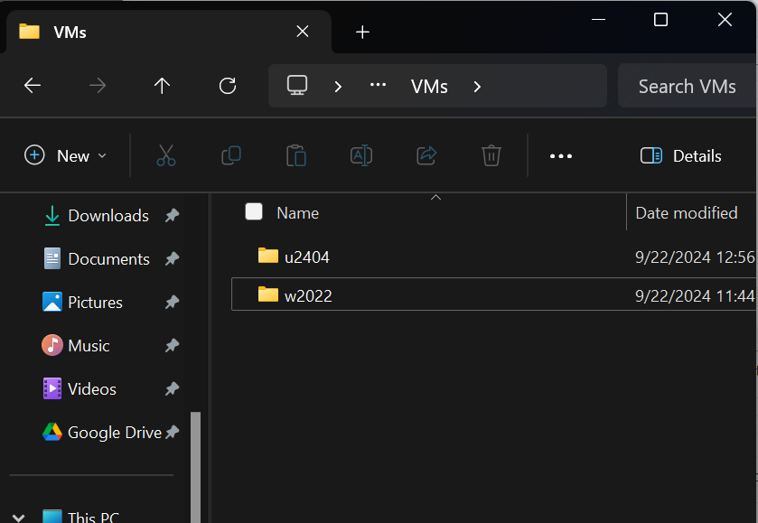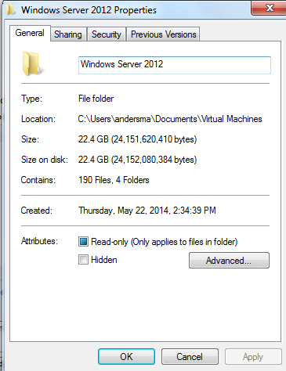
3.2 Performance Monitoring Ubuntu v14 and backup
- Run resmon (or use the performance tab on Task Manager) on your host machine and make note of the CPU & RAM usage.
- Run gnome-system-monitor in your Ubuntu VM and make note of the CPU & RAM usage
- Go to your Virtual Machine Settings, fine tune your VM and make a screen shot of your settings
- Backup your Ubuntu VM and make a screen shot of the properties of your backup folder.
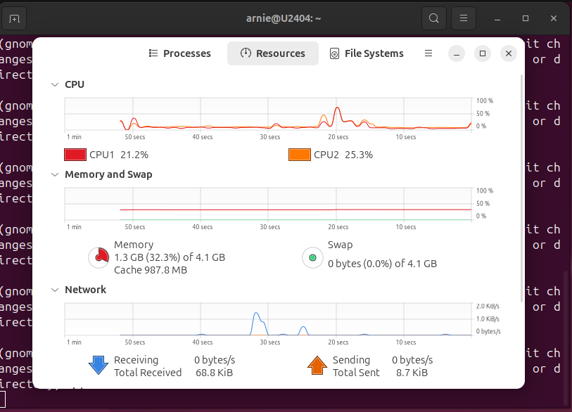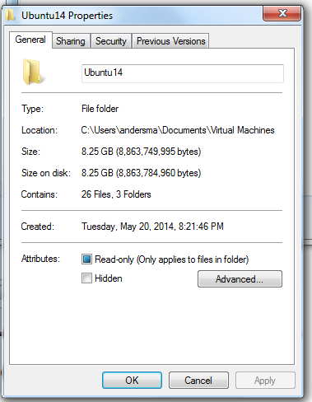
You’ll start experiencing performance degradation when either the CPU or Memory usage is greater than 70%. Throughout the remainder of the course, you’ll use these resource monitoring techniques to manage Web Server performance on your VM.
3.3 Linux Command Line Utilities
Start the terminal command and try the following commands. Insert screen shots of where requested.
- pwd - displays your current working directory (default directory)
- cd /lib - changes your current working directory to /lib
- ls - (stands for list) displays the contents of your current working directory
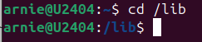
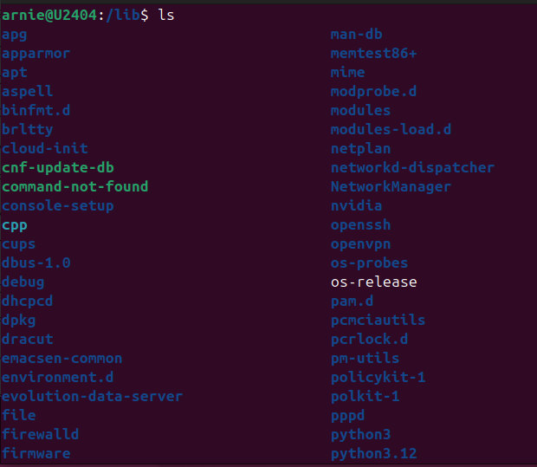
<insert a screenshot of the above three commands here>
- ls -l - (that's a lower case L at the end) displays a long listing of the current directory. Note that lines beginning with a 'd' are directories and lines beginning with a '-' are files. 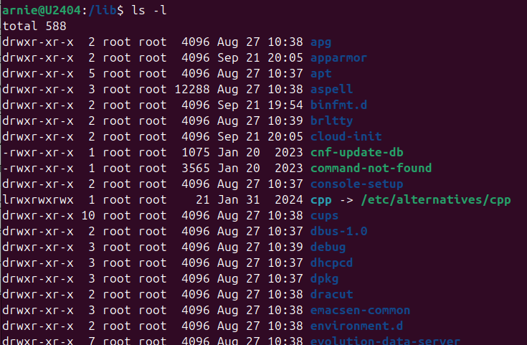
<insert a screenshot of the above command here>
- cd - changes your current working directory back to your home directory
- mkdir testdir - creates a directory named 'testdir' in the current directory
- ls -l - note that the 'testdir' directory is now created in your home directory
<insert a screenshot of the above three commands here>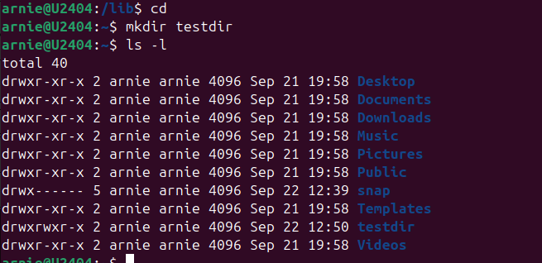
- touch newfile - creates a new, empty file named 'newfile'
- ls -l - note that the 'newfile' file is now created in your home directory
<insert a screenshot of the above two commands here>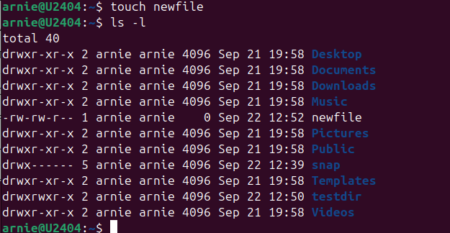
- rmdir testdir - removes the directory named 'testdir' (how can you look to see if it's really gone?
- rm newfile - removes the file 'newfile' (how can you look to see if it's really gone?)
- touch file1 file2 file3 - creates three new files named 'file1' file2' and 'file3'
- touch file10 file20 file30 - create three files named 'file10' file20' file30'
- ls file? - list all files starting with the word file and any single letter following
- ls file* - list all files starting with the word file and any number of letters following (note: the ? and * characters are called 'wild cards' because they do pattern matching)
<insert a screenshot of the above six commands here>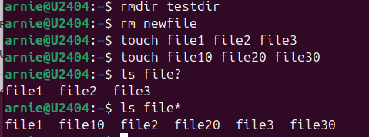
- ls file1* - explain the results of this command below (no screenshot required).

- ls file1? - Explain the results of this command (no screenshot required).

- mv file10 file100 - What does this command do? How can you verify the results?

Used in Unix-like operating systems to rename or move a file.

- rm file1? - Explain the results of this command (no screenshot required).
Used to remove files in Unix-like operating systems. The ? is a wildcard that matches exactly one character. Therefore, file1? will match any file that starts with file1 followed by exactly one additional character.

- rm file* - Explain the results of this command(no screenshot required).
Used to remove files in Unix-like operating systems. The * is a wildcard that matches zero or more characters. Therefore, file* will match any file that starts with the prefix file, followed by any sequence of characters (including none).

