Hands on Projects – Chapter 1 Worksheet:

Name: Arnie Marten
- Visit https://distrowatch.com/dwres.php?resource=major and find the list of Linux distributions. Choose three and briefly describe how they differentiate themselves. Which one would you choose for a Web Server and why? (3 points)

Here are my three chosen Linux distributions:

1. Ubuntu
- User-Friendly Interface: Ubuntu is well-known for its easy-to-use interface and extensive documentation, making it perfect for beginners.
- Regular Updates: It follows a predictable release cycle with Long-Term Support (LTS) versions receiving updates for five years.
- Community Support: A large community provides ample support and tutorials, making problem-solving easier.

2. Fedora
- Cutting-Edge Features: Fedora is often the first to integrate the latest technologies and innovations in the Linux world.
- Short Release Cycle: It has a rapid release cycle (approximately every six months), providing users with the latest software but may result in some instability.
- Red Hat Connection: As a community-driven project backed by Red Hat, it serves as a testing ground for features that may appear in Red Hat Enterprise Linux.

3. Debian
- Stability and Reliability: Debian is renowned for its stability and is often used as the base for other distributions.
- Long Development Cycle: Its releases are not as frequent, focusing on thorough testing and quality control.
- Variety of Architectures: Debian supports a wide range of hardware architectures, making it versatile for various use cases.

For a web server, I recommend Debian due to its stability, long-term support, and efficient package management using Advanced Package Tool (APT). These features align well with the needs of a web server environment.

- Complete the comparison matrix of Internet Service Providers available at your home address (or wherever you are staying). Include at least three providers. Indicate which provider you use and why. (3 points)

Provider Download Upload Latency DataCaps Price
X Stream 1 Gbps 50 Mbps UNK Unlimited $99.99/mo
Centurylink 100Mbsp UNK UNK Unlimited $55.00/mo

*only 2 ISP providers available in Virginia MN that are not Satellite Providers

- The purpose of tracert (trace route) is to display the names of router hops between two computers. Run tracert from the CMD prompt and insert a screenshot of the routers between your computer and www.google.com. Download a free graphical trace route program and repeat the exercise. Insert a screenshot below. (3 points)

Tracet – screenshot
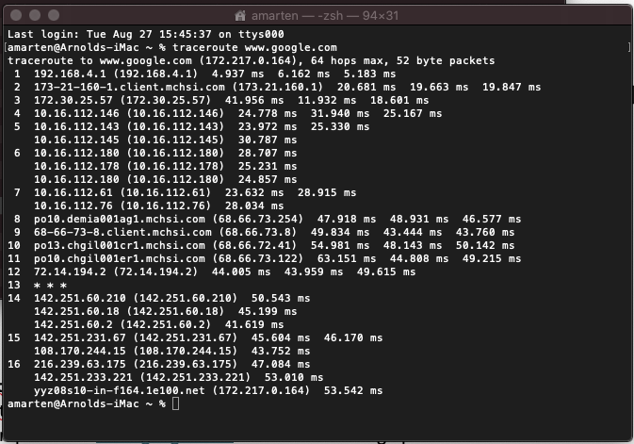

IP2Location.com – Screenshot
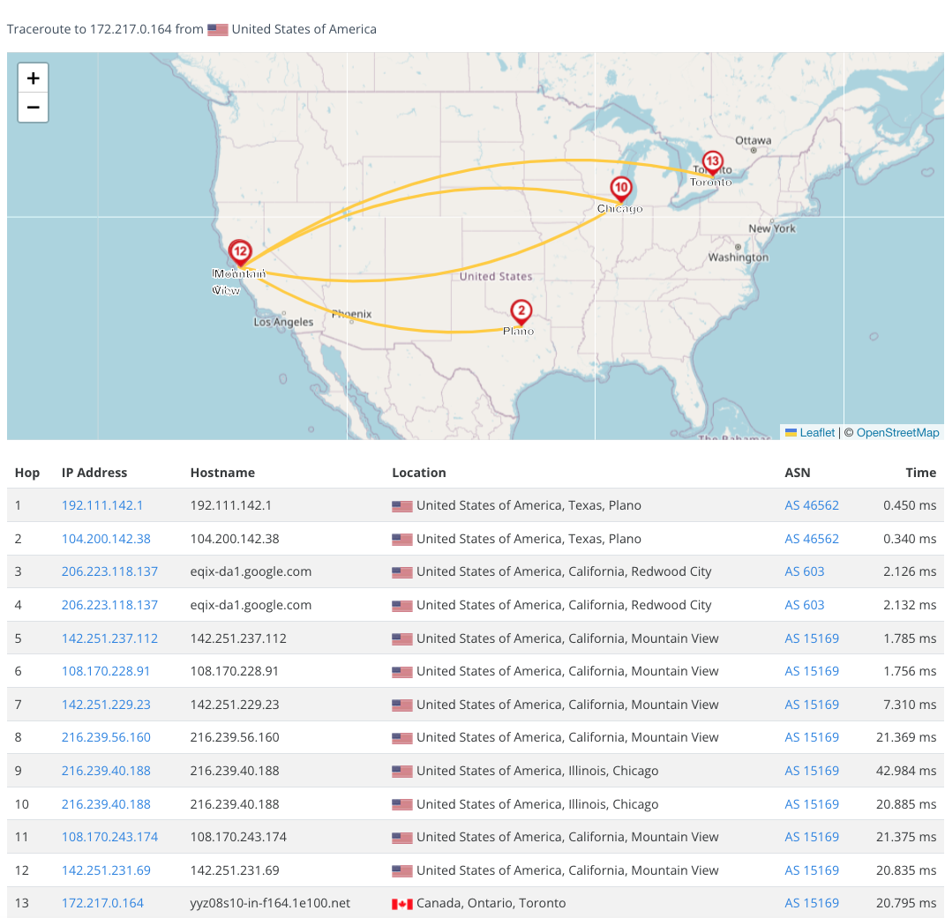

- We will use the standard edition of Windows Server 2022. Refer to the hyperlinks below to answer these questions: (6 points)

  - What are the editions that Microsoft is offering and what are their intended use?

Microsoft offers three editions of Windows Server 2022 to meet various business needs. The Standard Edition is suitable for physical or minimally virtualized environments, providing essential features for most businesses, including basic virtualization support. The Datacenter Edition is designed for highly virtualized data centers and cloud environments, offering all Standard features along with additional capabilities for unlimited virtualization and advanced features like Software-Defined Networking and Storage. The Datacenter: Azure Edition is tailored for users running Windows Server in Azure, with features optimized for cloud environments, such as enhanced security and hybrid capabilities. These editions cater to a wide range of business needs, from small businesses to large enterprises with complex IT infrastructures.

  - What is the maximum RAM addressable with the Standard edition?

4 TB

  - We’re installing Domain Name Services in Chapter 3, Web Server in Chapter 6, and SQL Server in Chapter 7. Which Server Roles will we use?

Domain Name Services (DNS) - The server role used will be DNS Server. This role allows the server to resolve domain names to IP addresses.

Web Server - The server role for this installation is Web Server (IIS). This role enables the server to host websites and web applications.

SQL Server - The server role for this will be SQL Server Database Engine. This role allows the server to handle database management and queries.

- https://www.windowscentral.com/all-three-editions-windows-server-2022-are-here
- https://www.microsoft.com/en-us/windows-server/pricing
- https://learn.microsoft.com/en-us/windows-server/get-started/editions-comparison?pivots=windows-server-2025

